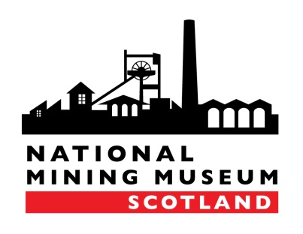
Marketing & Events Manager
National Mining Museum Scotland
Lady Victoria Colliery, Newtongrange EH22 4QN
Fax: 0131 654 1618
Email: marketing@nationalminingmuseum.com
FILMING / PHOTOGRAPHY ENQUIRY FORM
The museum welcome filming and photography by prior arrangement only. All proposed projects will be assessed in terms of the relevance to the Museum, their impact upon the museum’s core activities and public duties and the availability of museum staff to supervise the work.
No filming/photography can take place until full details of the proposed project, signed risk assessment and T&Cs have been received and agreed by the museum. We recommend that you undertake a recce visit to familiarise yourself with the museum and ensure we can fulfil your requirements.
The museum reserves the right to decline permission for filming/photography, to charge a fee and/or restrict the length of filming/photography. Fees/timings will be agreed on an individual basis.
The following information must be provided at least 14 days in advance.
Name of company:
Name of key contact:
Address:

Work telephone number:
Mobile telephone number:
Email address:
Would you like to undertake a recce visit and, if so, when?
Name of Project:
What is the purpose of this filming/photography? (please attach a project brief and state whether it is commercial/non-commercial, news, documentary etc)
Has this project been commissioned and, if so, by who?
What are the proposed dates/times and duration of the filming/photography?

What is the proposed date of broadcast/publication?

Please outline the full filming/photography schedule (including details of objects/locations to be filmed/photographed):

What equipment will be used (please provide a full list, including vehicles and any special structures e.g. lighting frames/towers)?

Please provide us with the names of all staff/crew involved:

Will you require access to a mains electricity supply? Please note that any electrical equipment plugged into our supply must be PAT tested.

Will there be an opportunity to credit National Mining Museum Scotland and, if so, where?

Do you require interviews with staff? Please provide full details of who you would like to interview and an outline of the topics/questions you would like to cover. (Please note that we will charge a fee should you wish to interview members of staff on a day outside of their normal working week.)
Will you require access to areas not usually open to the public? (Please note that any such requests must be approved by our Technical Services Manager in advance)
Insurance is the responsibility of any crew/individual who films/photographs at the museum. Please supply the same of your insurance company and the policy number.
Do you have any other requirements?

Date of enquiry:

PLEASE NOTE THAT THIS IS AN ENQUIRY FORM ONLY AND DOES NOT CONSTITUTE AN AGREEMENT. WE WILL USE THIS INFORMATION TO DISCUSS YOUR NEEDS FURTHER AND DECIDE WHETHER WE CAN SUPPORT YOUR REQUEST/AGREE TERMS AND CONDITIONS.

