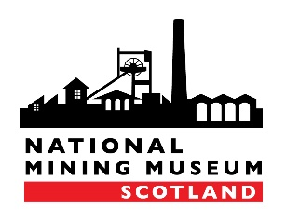
NMMS Application Form
Collections Volunteer

Contact Information
First Name
Surname
Address
Postcode
Contact Telephone
Email

About You
Why would you like to volunteer at the National Mining Museum Scotland?

What skills/knowledge do you feel you could bring to the Museum? Please include any hobbies or life experience that you think could be relevant.

Using a computer is an important part of the Collection Volunteer role. How would you describe your IT skills? Please note that training is provided.

Do you have any support needs we can help with?

Select any of the following areas which might be of interest to you. You can select more than one option.
Please note that training would be provided in all areas.

Cataloguing (library, maps, plans, documents etc.)
Researching enquiries
Transcription (oral history interviews, documents etc.)
Recording information about objects into a database
Digitisation (scanning, using a camera etc.)

Availability
What is your availability?
 | Monday | Tuesday | Wednesday | Thursday
AM
PM

