BECOME A FRIEND 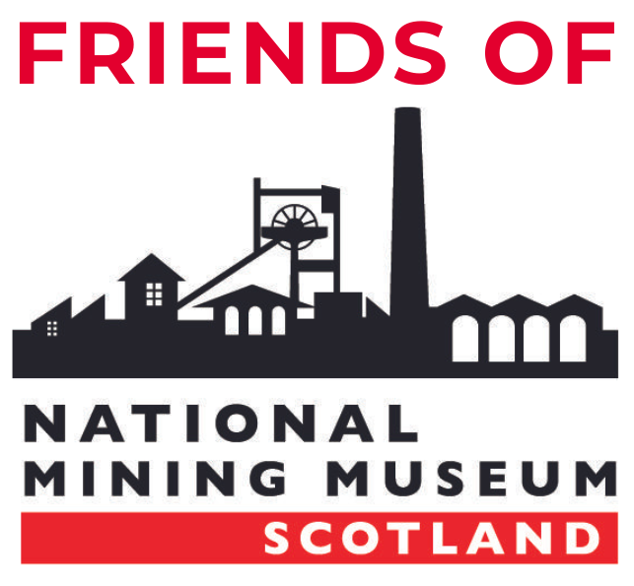

I wish to join the Friends of National Mining Museum Scotland.

MEMBERSHIP

Please tick as appropriate:

- Individual Annual Membership £20
- Family Annual Membership £30

PERSONAL DETAILS

Full Name(s) ………………………………………………………………………………………………………………
Home Address ………………………………………………………………………………………………………….
……………………………………………………………………………………………………………………………………………
Email …………………………………………………………………………………………………………………………….

- I would like to subscribe to the NMMS email newsletter. We will only use the information you provide to administer your Friends membership and to send you emails if indicated.

PAYMENT

Please tick as appropriate:

- I enclose a cheque for £20/£30 payable to “The Friends of the National Mining Museum Scotland”
- I will make a payment by bank transfer using the following details: Sort Code 82-69-34 Account Number 80063612

.

Please return to: Membership Secretary, National Mining Museum Scotland, Lady Victoria Colliery, Newtongrange, Midlothian, EH22 4QN

Friends of National Mining Museum Trust is a charity registered in Scotland (No. SC022093). Registered Address: 8 Edgehead Road, Pathhead, Midlothian, EH37 5RJ.

